Data Health Management

Merge Rules
Step 1: Merge Accounts
Merging happens first at the Account level between 2 Accounts. When all the Contacts within 1 Account match with another Account based on the provided criteria then the 2 Accounts and all the Contacts are merged into a single Account. Only the Accounts are merges along with all the Contacts. There is no Contact merging in this step.
Example: Account 1 with 2 Contacts and Account 2 with 4 Contacts, Account 1 with 2 Contacts matches 2 Contacts within Account 2 then Accounts are merged. The Accounts don’t need the same number of Contacts but all of the Contacts within one of the Accounts need to match.
Step 2: Merge Contacts within an Account
When 2 contacts are matching within the same Account based on the provided criteria then they are merged into a single Contact in the Account.
NOTE: 2 Contacts are never merged between 2 different Accounts. That is not done because would create an imbalanced household Account that doesn’t reflect the actual household size.
There are 2 Flows that manage the Duplicate process
- Mass Merge - Discover Duplicate Accounts
Oppco: Mass Merge - Discover Duplicate Contacts
- Mass Merge - Discover Duplicate Contacts
Oppco: Mass Merge - Discover Duplicate Accounts
These Flow each have Action elements that call into APEX functionality that looks for duplicates and merges them when found.

For instance (refer to Figure 1), this is one of the actions in the Mass Merge - Discover Duplicate Contacts. Contacts within Accounts that have matching FirstName, LastName, and DOB.
When you click on the action you can see the matchingFieldsCSV - this is where you put the Fields that you want to match contacts on to find the Duplicate.
This is where you will manage the duplicate process from. For instance, if you also want to match based on Gender then you’d add ,Gender__c (API name) to the list of fields. The other option if you want to add a completely different list of matching fields you can add a new action.
Click the + in the flow then select Action and search ‘Start Duplicate Check Batch’ and add the APEX action. Then you can add your own list of fields to merge Contacts Within an Account.
Similarly for the Account merge you can add the same action - except the objectType is Account instead of Contact. The Account merges the specific contact match fields but in the Account merge case all the Contacts from one Account need to match all the contacts for another Accounts based on the match fields before the two accounts are flagged as merge candidates and automatically merged.
Those are the two scenarios for merging
1. Contact Merging - Duplicate Contacts within the same Account
- Account Merging - Duplicate Accounts where all Contacts from one Account matching to all contacts from another Account

Figure 1: Contacts Within Account
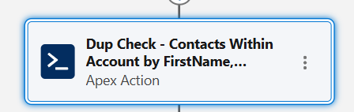
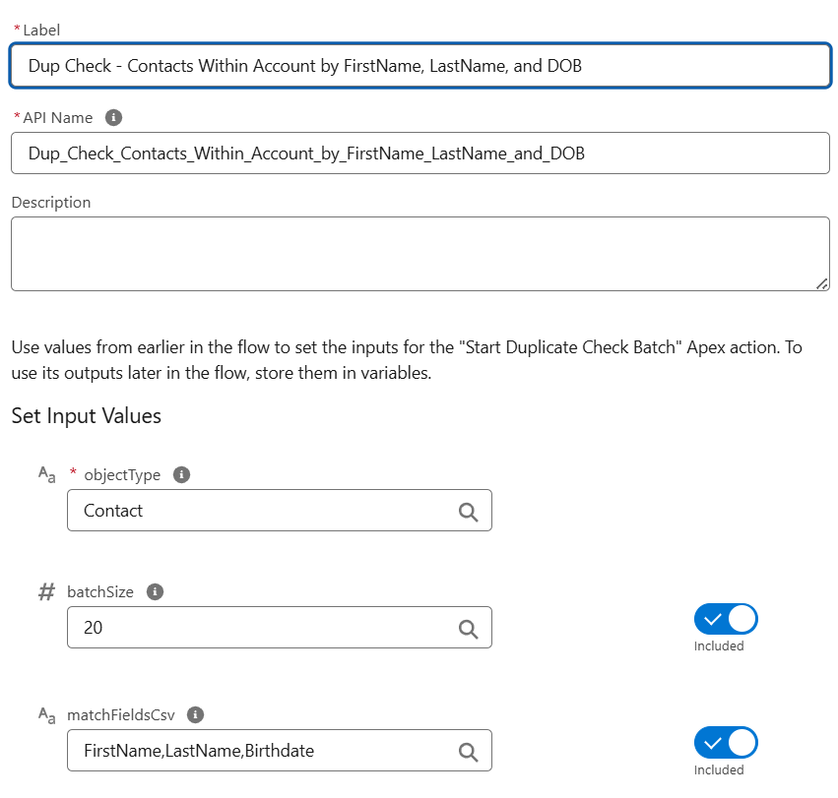

Figure 2: Accounts

Figure 3: Dashboard & Reporting

